ENTRANCE

PRELUDE

WELCOME AND ANNOUNCEMENTS

*BRINGING IN THE LIGHT OF CHRIST

*CALL TO WORSHIP
Listen, for the voice of God comes near!
Listen, for God’s voice is not obstructive.
We come to worship the God who became one of us,
Who calls us by name,
Who is Love Incarnate,
Who is!
Let us gather together in joy and hope.
Let us worship the God of Love!

*OPENING HYMN
Sanctuary (2164 TFWS)

*OPENING PRAYER
Loving God, we confess that we are selfish people, who want what you can give us, more than we want You. We thank you for loving us enough to give us more; to give us your very life, offered on the cross, for the forgiveness of our sins. Make us like Christ, who did not seek to be served, but serve. We pray this in his precious name. Amen.

*PASSING OF THE PEACE

CHILDREN’S MESSAGE
PROCLAMATION

PRAYER FOR ILLUMINATION
Almighty God, your ways are higher than our ways. Your thoughts are higher than our thoughts. Give us humility to think less of ourselves. Give us eyes to see how much we depend on your love and grace. Give us faith to trust you more deeply today than we did yesterday. Amen.

EPISTLE READING
Psalm 104: 1-9

GOSPEL READING
Mark 10:35-45

SONG OF PREPARATION/ANTHEM

MESSAGE
Learning to Serve and Love.

RESPONSE

*APOSTLES’ CREED (#881 UMH)
I believe in God the Father Almighty, maker of heaven and earth; and in Jesus Christ his only Son our Lord: who was conceived by the Holy Spirit, born of the Virgin Mary, suffered under Pontius Pilate, was crucified, dead, and buried; the third day he rose from the dead; he ascended into heaven, and sitteth at the right hand of God the Father Almighty; from thence he shall come to judge the quick and the dead. I believe in the Holy Spirit, the holy catholic church, the communion of saints, the forgiveness of sins, the resurrection of the body, and the life everlasting. Amen.

Celebration of God’s Tithes and our Offerings

*DOXOLOGY (#95 UMH)

Offering should be placed in the plate before service.

PRAYERS OF THE PEOPLE

THANKSGIVING AND COMMUNION
(Marshall Only)

*CLOSING HYMN
Lord, I Want to Be a Christian (402)

SENDING FORTH

*CARRYING OUT THE LIGHT OF CHRIST

*BENEDICTION

*RESPONSE #672
“God Be with You Till We Meet Again”
Verse 1

Participating Today at Markham
Lay Speaker and Leader: Sal Ortiz
Music: Laurie Bersack
Worship Leader: Bonnie Schmidt

Participating Today at Linden
Lay Speaker and Leader: Sal Ortiz
Music: Laurie Bersack
Worship Leader: John Kokernak

Participating Today at Marshall
Lay Speaker and Leader: Sal Ortiz
Music: Ruth Umbel
Worship Leader: Joe Bersack
Communion Stewards: Terri Hill
Counters: Jeff Machamer and Terri Hill
A/V Team: Amy Taylor

Next Week
October 24, 2021
Pastor: John Rowe
Scripture: Mark 10:46-52
Sermon: Hope for the blind
Worship Leaders:
Bonnie Schmidt – Markham
Sal Ortiz – Linden
Amy Taylor – Marshall
Counters:
Amy Taylor and Cathy Harris – Marshall
Communion Stewards:
Terri Hill – Marshall

ANNOUNCEMENTS

Prayer Requests: If you have a prayer request during the week, please send it to prayers@marshallumc.org and/or Pastor John.

Newsletter: If you have anything for our newsletter, please send it to Marti Church at
admin@marshallumc.org by the 25th of each month.

Linden Sunday School: Our Sunday School class continues watching the series, The Chosen, and discussing it. You are invited at 11am.

Marshall Sunday School: Please join us next week at 10am for both children and adult Sunday School classes.

Marshall Movie Night and Trunk or Treat: We will be having both events on Saturday October 30. The Trunk or Treat will run from 4:30-6:30pm. Movies will start at 7pm, beginning with “The Great Pumpkin Charlie Brown” and then “The Nightmare Before Christmas.” We still need volunteers and donations for both events. Please see pastor John or Michelle.

LINDEN, MARKHAM, MARSHALL UMC COOPERATIVE PARISH

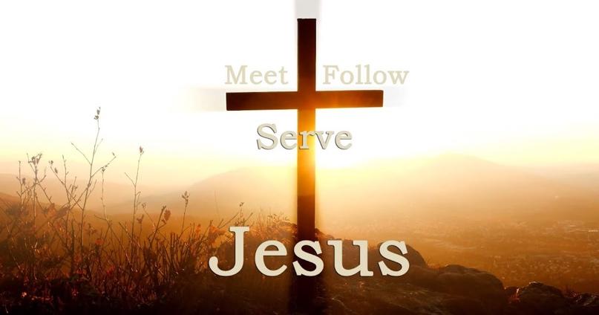

Laity Sunday
21st Sunday after Pentecost
October 17, 2021
Markham @ 8:15am
Linden @ 9:30am
Marshall @11:00am

